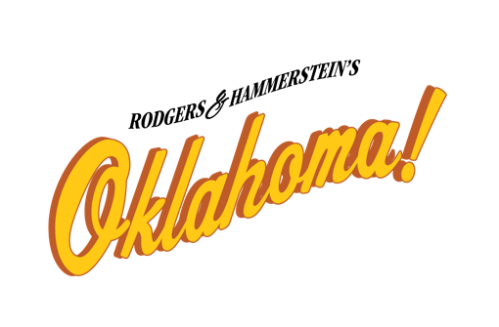
The Ford Center for the Performing Arts

Performances: Friday, June 28 and Saturday, June 29, 2024
Auditions: Sunday, March 24, 2:00 p.m. – 5:00 p.m. with callbacks following

AUDITION INFORMATION & CONFLICT SHEET
Please fill out completely.

NAME: _______________________________________________ Height: ______________

ADDRESS: ____________________________________________ Weight: ______________

CITY: ________________________________________________ Hair color: ____________

PHONE: _____________________________________________

EMAIL: ______________________________________________

Voice type – (circle one) (S, A, T, B) Range:____________ Do you read music? (circle one) Yes No

REHEARSALS BEGIN TUESDAY MAY 28 for some cast members.

PLEASE LIST YOUR AVAILABILITY BELOW BY CHECKING THE APPROPRIATE LINE.

I AM AVAILABLE FOR REHEARSAL WEEKDAY MORNINGS. ___
I AM AVAILABLE FOR REHEARSAL SATURDAY MORNINGS. ___
I AM AVAILABLE FOR REHEARSAL WEEKDAY AFTERNOONS. ___
I AM AVAILABLE FOR REHEARSAL SATURDAY AFTERNOONS. ___
I AM AVAILABLE FOR REHEARSAL WEEKDAY EVENINGS. ___
I AM AVAILABLE FOR REHEARSAL SATURDAY EVENINGS. ___

Please list single slot conflicts here: No conflicts accepted from June 22 – June 29.

_____________________________________________________________________________________

_____________________________________________________________________________________

If you are interested in a staff, crew or intern position, please list your skills: (carpentry, stage management,
costumes, props, painting, etc.) and list your experience in these areas:

______________________________________________________________________________________

_______________________________________________________________________________________

_______________________________________________________________________________________

